Profile

TC_091

Ensure users can log in successfully with valid credentials

1. Open the Login page  
2. Enter a valid username  
3. Enter a valid password  
4. Click the Login button

The user should be successfully logged in and redirected to the home/dashboard page

TC_092

Ensure the password visibility icon allows users to view/hide their password

1. Open the Login page  
   2. Enter a password  
   3. Click the eye icon to reveal the password  
   4. Click the eye icon again to hide the password

Working as expected

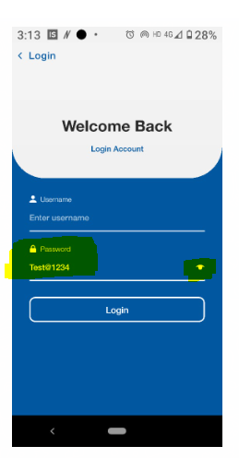

TC_093

Ensure the login system is case-sensitive for both username and password

1. Open the Login page  
2. Enter a valid username but with different casing  
3. Enter a valid password but with different casing  
4. Click Login

The system should deny access due to incorrect credentials

TC_094

Ensure login fails when an incorrect username is entered

1. Open the Login page  
   2. Enter an incorrect username  
   3. Enter a valid password  
   4. Click Login

Working as expected

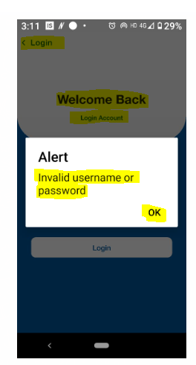

TC_095

Ensure login fails when an incorrect password is entered

1. Open the Login page  
2. Enter a valid username  
3. Enter an incorrect password  
4. Click Login

The system should display an error message: "Invalid Username or Password"

TC_096

Ensure login cannot proceed with empty username or password

1. Open the Login page  
   2. Leave the username field empty and enter a password  
   3. Click Login  
   4. Now, enter a username and leave the password empty  
   5. Click Login

The system is displayed an error message for Please enter login credential!

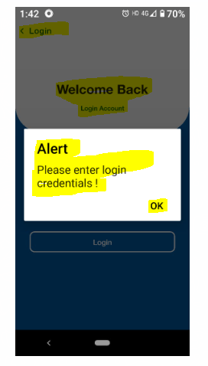

TC_097

Ensure the system locks an account after multiple failed login attempts

1. Open the Login page  
2. Enter an incorrect password multiple times (e.g., 5 attempts)  
3. Observe system behavior

The system is not lock the account and not displaying a error message: "Too many failed attempts. Try again later."



TC_098

Ensure the system logs out inactive users automatically after a defined period

1. Login with valid credentials  
2. Leave the session idle for a specified time (e.g., 15 mins)  
3. Try performing any action

The system should log out the user and redirect to the login page

TC_099

Verify that the login screen provides an option to create a new account if the user does not already have one

1. Open the Login page  
2.Navigate to the Login screen

The login screen is not having an option to create account

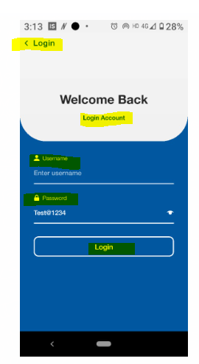

TC_100

Ensure the login process handles slow or unstable internet properly

1. Reduce internet speed (e.g., use a slow network)  
2. Try logging in  
3. Observe system behavior

The system should display a message: "Network issue. Please try again."